Job Description ESP/CCGEAM18

Project: Connswater Community Greenway

Job Title: Events and Activities Manager

Location: EastSide Partnership, Avalon House

Reports to: Connswater Community Greenway Trust Manager

Terms and conditions

Salary: NJC Point 26 – 31, currently £23,866 - £28,221 + 7.5% pension

Contract: This is a permanent post. Job subject to 6 month probation period.

Holidays: 25 days per year plus statutory holidays.

Hours of work: 37.5 hours per week but willingness to work flexible hours including evenings and weekends is essential.

The following gives an indication of the current main duties and responsibilities of the post. The post holder will be expected to work flexibly and carry out any other duties appropriate to the role which may reasonably be required from time to time.

Main Purpose of Job
The main purpose of this role is to:

Deliver an animation and events programme for the Connswater Community Greenway to ensure that it is welcoming, well used and an attractive place to visit, explore and enjoy.

Establish and develop the C.S. Lewis Square as an events ‘venue’ attracting a range of community, arts and animation activities.

Provide event management support to others including the EastSide Partnership group of companies, local communities and the public and private sectors.

Summary of responsibilities and personal duties

- Deliver an annual animation programme of events and activities in the parks and open spaces along the Connswater Community Greenway

- Develop and deliver events and activities which encourage positive use and meet the strategic objectives of the CCG; social, economic, community and environmental
- Work with stakeholders along the CCG including businesses, schools and colleges, residents and community groups to deliver bespoke programmes of activity

- Develop and promote the use of the C.S. Lewis Square as an outdoor venue

- Encourage the use of the C.S. Lewis Square as a community asset on a day to day basis
- Further develop the C.S. Lewis Square as an events venue promoting positive use and attracting visitors to the space
- Build relationships with local stakeholders and event promoters locally, nationally and internationally
- Develop a marketing plan to promote the C.S. Lewis Square as an events venue in the context of the CCG and the wider EastSide area
- Develop a business plan for C.S. Lewis Square to ensure sustainability of the space as an events venue

- Provide event management support to others including the EastSide Partnership (ESP) group of companies, local communities and the public and private sectors

- Build relationships with ESP companies and encourage animation and activity which delivers their strategic objectives (arts, tourism, education etc.)
- Deliver a high standard of customer service to event audiences as well as clients, artists and promoters
- Ensure that all delivered programmes, events and activities on the CCG comply with relevant legislation, health and safety requirements including risk assessment and current best practice
- Ensure that the appropriate licensing arrangements and event protocols are in place working alongside the relevant Belfast City Council (BCC) departments
- Ensure that all events and activities are well organised and have the appropriate management systems in place including event plans
- Ensure that events are attractive, welcoming and appealing

- Undertake other duties relevant to the role including:

- Manage relevant and appropriate resources/ equipment to support the operational delivery of an event or activity
- Ensure that the outdoor spaces are well maintained prior, during and after an event working alongside the relevant agencies at BCC
- Ensure that events and activities are staffed well working with EastSide Partnership staff and volunteers including Greenway Leaders, Belfast City Council staff and external event organisers
- Work alongside communications staff at ESP and BCC to ensure all events are well marketed and promoted to maximise participation
- Deliver events and activities within the approved budgets and apply for and source external budgets when required
- Report against objectives to ensure outcomes are being met and that monitoring and evaluation is undertaken
- Act in accordance with EastSide Partnership’s policies and procedures
- Undertake such other relevant duties as may from time to time be required

Person Specification ESP/CCGEAM18

 | Essential | Desirable
Experience | - A minimum of 2 years’ experience gained in the last 5 years;  - Managing and delivering events and activities  - Managing budgets  - Establishing and maintaining excellent working relationships and partnerships with a broad range of stakeholders, individuals and organisations | - Experience of community development  - Experience of partnership working  - Management of staff and volunteers
Attainments/ Education | - A third level qualification | - A management qualification  - A recognised qualification/ training in health and safety and/ or risk management
Skills | - Ability to communicate effectively including excellent social skills and the ability to converse with a diverse range of people at all levels  - Ability to be creative, innovative and work on initiative  - Effective organisation skills with the ability to manage and prioritise workload and meet deadlines  - Experience of identifying and using resources to deliver projects/ events/ activities | -Experience of writing successful funding applications
Disposition | - Well presented & inspires confidence  - Self-motivated and initiative taking  - Ability to work collaboratively and as part of a team  - Flexible and pragmatic  - Creative and innovative
Knowledge & Values | - Knowledge of Connswater Community Greenway and EastSide Partnership  - Commitment to regeneration and a partnership approach
Circumstances | - Willingness to work flexible hours including evenings and weekends

Application Process ESP/CCGEAM18

Application
- Completed applications must arrive by 3.00pm on Wednesday 4th July 2018

- Applications will only be accepted by email to heather@eastsidepartnership.com and will be acknowledged by email. If not acknowledged please contact Heather on 028 9045 1900

- Application MUST be by letter outlining how you meet all of the criteria in the person specification. The letter must be no longer than 2 x A4 pages, (minimum font size 10). You may also include a CV (max 2 x A4 pages, minimum font size 10) but please ensure that if you enclose a CV, you cover how you meet all criteria as detailed in the person specification, in your letter

- To be accepted the application must include the monitoring form

- EastSide Partnership is only able to accept applications from those individuals who are currently eligible to work in the UK.

- We may only interview those applicants who appear, from the information provided, to be the most suitable in terms of the person specification provided.

Equal Opportunities
- EastSide Partnership is an equal opportunities employer. EastSide Partnership does not permit unlawful discrimination of any kind against any person on grounds which include gender, sexual orientation, marital status, religious belief or political opinion, race or disability. Unlawful discrimination is defined as treating a person less favourably than others are, or would be treated in the same or similar circumstances.

Canvassing
- Canvassing in any form will, if proved to the satisfaction of EastSide Partnership, disqualify a candidate for the appointment

Interviews
- Interviews will be held on Monday 23rd July 2018. Please ensure your availability for interview on this date prior to application, as it will not be possible to arrange an alternative date

Job Description
- The duties outlined in the Job Description serve as a guide to the current and major responsibilities of the post. These will inevitably vary as the role develops and the Job Description will be reviewed on a regular basis. Changes will be subject to consultation with the post holder.

For office use only
App Ref:

Equal Opportunities Monitoring Form ESP/CCGEAM18

Ref No: ESP/CCGEAM18 Private & Confidential

We are an Equal Opportunity Employer. We do not discriminate on grounds of religious belief or political opinion. We practice equality of Opportunity in employment and select the best person for the job.

To demonstrate our commitment to equality of opportunity in employment we need to monitor the community background of our applicants and employees, as required by the Fair Employment and Treatment (NI) Order 1998.

Regardless of whether we practice religion, most of us in Northern Ireland are seen as Catholic or Protestant. We are therefore asking you to indicate your community background by ticking the appropriate box below.

I am a member of the Protestant community

I am a member of the Roman Catholic community

I am a member of neither the Protestant nor Roman
Catholic community

Please indicate whether you are: Female

Male

If you do not complete this questionnaire, we are encouraged to use the “residuary” method, which means that we can make a determination on the basis of personal information on file/application form.

Note: It is a criminal offence under the legislation for a person to “give false information in connection with the preparation of the monitoring return”.

Background Information

EastSide Partnership is a regeneration charity which delivers a wide variety of projects with a clear mission, ‘to make east Belfast a better place’ for resident and visitors. We work with local councils, statutory agencies, community organisations, elected representatives and businesses to make east Belfast a great place to live, work, visit, invest and be proud of.

Our vision is that east Belfast will be a great place where:
- Residents enjoy good health and well being
- Education is valued and high standards achieved
- Tourism, arts and hospitality are thriving

EastSide Partnership aims to:
- Contribute to physical regeneration in east Belfast by developing key properties through Landmark East
- Ensure the Connswater Community Greenway is developed and maintained as a destination for all and deliver similar initiatives
- Deliver EastSide Arts festivals, community arts projects and support local arts groups
- Help schools and communities work together to deliver better opportunities for children through EastSide Learning
- Develop the tourism and heritage product to encourage more visitors

The Connswater Community Greenway (CCG) is a 9km linear park through east Belfast, following the course of the Connswater, Knock and Loop Rivers, connecting the open and green spaces and remediating the Connswater River itself. The Greenway reconnects the communities of east Belfast and restores the rivers as community assets. It has created vibrant, attractive, safe and accessible parkland for leisure, recreation and community events and activities.

Connswater Community Greenway improves the living environment, reinstating a valuable amenity for local people and provides opportunities for improving health and well-being. The CCG acts as a catalyst for physical and economic development and improves access and connections for local communities.

The vision for the Connswater Community Greenway is;

‘An inspirational living landmark that is well used, vibrant, dynamic and sustainable. An attractive destination of outstanding quality for everyone to enjoy.’

C.S. Lewis Square

Green Living Market at C.S. Lewis Square Aslan, C.S. Lewis Square

Completed in November 2016, the C.S. Lewis Square is one of the most exciting new event spaces in Belfast, at the heart of the Connswater Community Greenway. Adjacent to the Square is the EastSide Visitor Centre, an innovative building which contains visitor information, a coffee shop and a gallery/ meeting space.

The C.S. Square features over native 300 trees and seven statues inspired by The Lion, the Witch and the Wardrobe by Irish artist Maurice Harron. This fantastic open space regularly hosts community events, markets, music, fitness classes and much more.

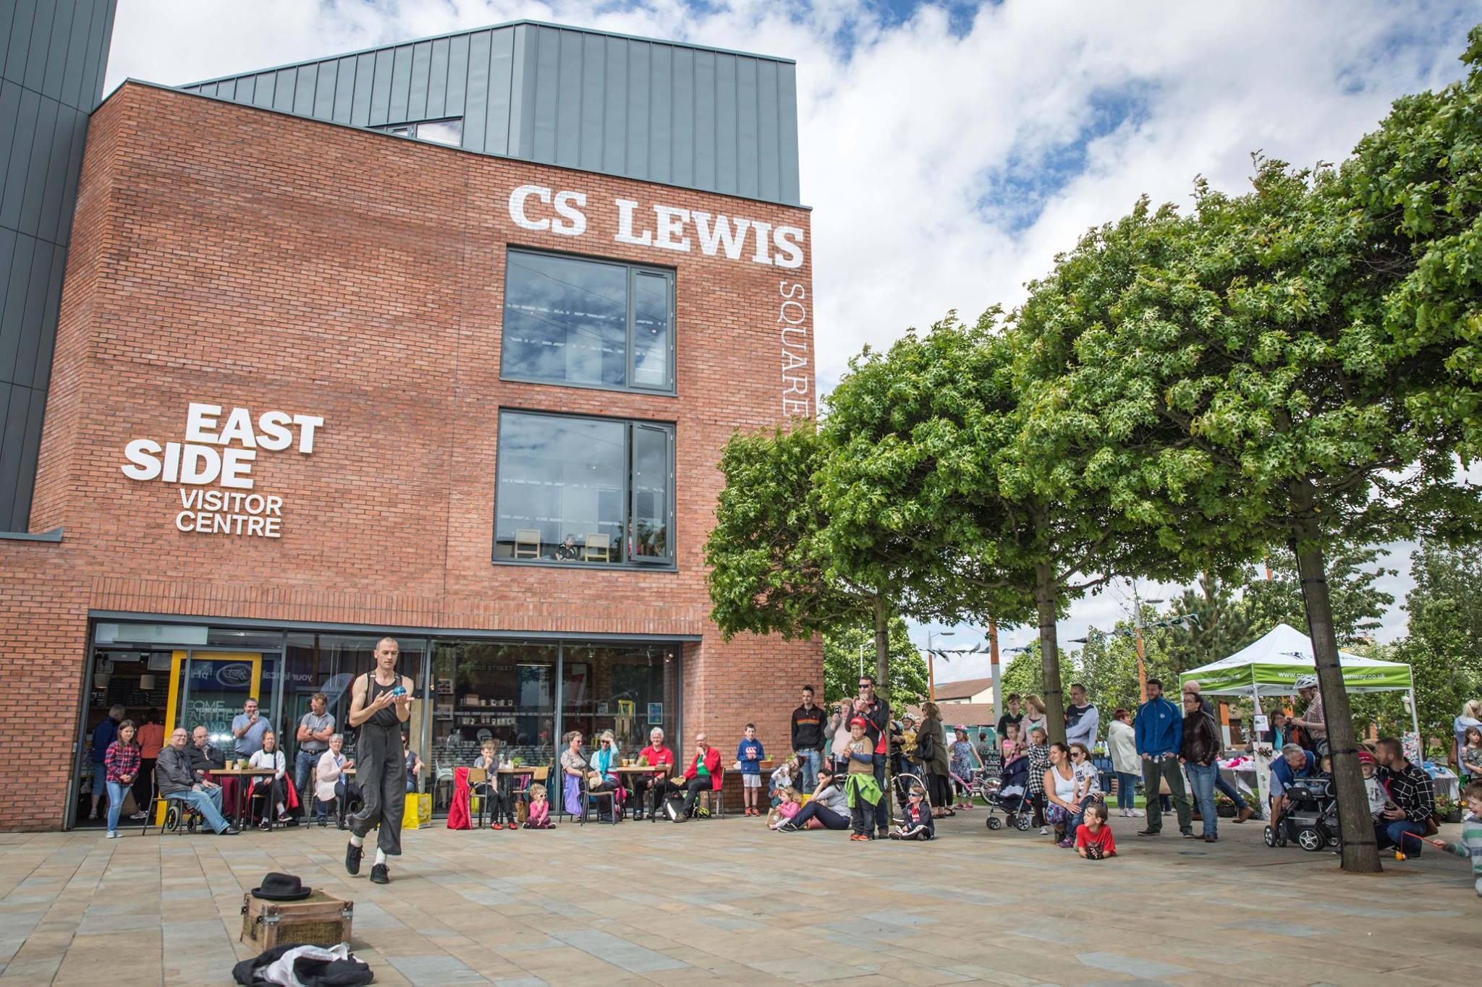
EastSide Visitor Centre at C.S. Lewis Square

