2018 Room Hire Information
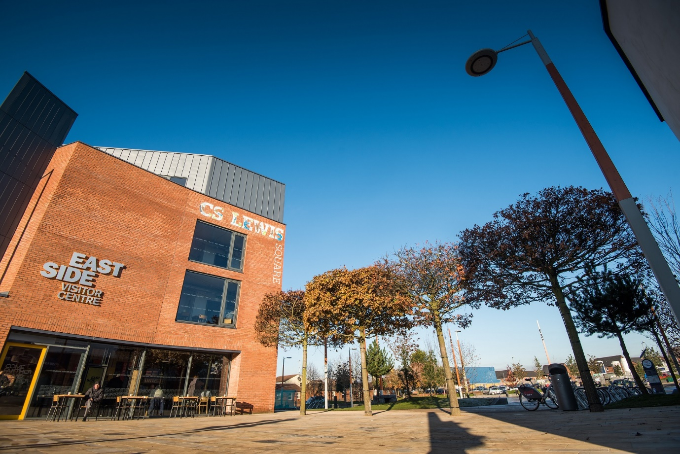

EastSide Visitor Centre
402 Newtownards Road
Belfast
BT4 1HH
Room Hire Request
EastSide Gallery
Contact Information
Primary Contact Name:
Name of Organisation:
Nature of Business:

Business Address:

Email:
Telephone:

Event Information
Title of Event:
Date:
Start Time:
Finish Time:
No. of Attendees:
Equipment Required: | Flipchart, Paper & Pens / Digital Projector & Screen  (Delete as appropriate - see rental cost overleaf)
Catering Required: | Yes / No  (Please see catering menu overleaf for more details)
Special Requirements: | Please indicate how you would like the room setup on arrival – see overleaf for more information.
How did you hear about us?

Please complete and return this booking form to visitorcentre@eastsidepartnership.com.
If catering is required, please include details in your Room Hire Request email.
See catering menu overleaf for more information.
Additional Information
EastSide Gallery is 56 sqm and is located on the Second Floor of EastSide Visitor Centre.
Room Setup | Capacity
Standing Only | 50 People
Theatre Style | 40 People
Boardroom Style | 30 People
Classroom Style | 24 People
Banquet Style | 24 People

Cost
Room Hire Rates as follows;
Duration | Full Rate | Charity Rate
Half Day | £85 | £65
Full Day | £135 | £100
Evening Rate (after 5pm / until 10pm) | £100 | £80

Equipment
The following equipment is available to rent;
Item | Cost
Flipchart, paper & pens | £10
Digital Projector & Screen | £10

Catering by Pot Kettle Black
Please include any catering requirements in your Room Hire Request email
BREAKFAST | £ Per Person
Flasks of Tea & Coffee | £2
Freshly baked scones served with butter and jam | £2
Traybakes | £2
Fruit bowl, market fruit, pistachio & yoghurt | £3.50
Granola bowls with honey, yoghurt & berries | £3.50
Selection of fresh baked pastries, Danish, croissants, scones, cream, butter & jam | £5
Breakfast rolls, crispy bacon, hens egg, roast mushroom & watercress | £5
Ulster fry, crispy bacon, pork & apple sausage, hens egg, mushroom, potato bread, black pudding | £7.50
LUNCH | £ Per Person
Gourmet Sandwiches;  - Turkey, stuffing & cranberry  - Pastrami, roast pepper & relish  - Irish ham, cheddar & crispy onion  - Roast beef & horseradish  - Chicken Caesar  - Roast pepper, hummus & spinach | £ 4.25
Soup  - Tomato & basil  - Carrot & cumin  - Potato & white onion  - Sweet potato & coconut | 3.50
Salads  - Chicken Caesar, aged parmesan, crouton, crispy bacon  - Salmon nicoise, hens egg, fine beans, confit tomato, pickled shallot  - Red onion, tomato & rocket salad, aged parmesan, balsamic  - BBQ aubergine, cous cous, roast pepper & virgin oil salad  - Thai prawn cocktail, baby gem, spiced cocktail sauce,  - tomato & spring onion | £8.25
Finger Food  - Crispy chicken goujon’s  - Mini beef & cheddar slider  - Mini fish and chip cone  - Pea & mint arancini  - Crispy chilli squid  - Mini hot dog, sauerkraut  - Tempura asparagus | £10.50  (3 items)
Hot Fork Buffet  - Beef caseroule, roast onion, mushroom, red wine jus, new potatoes  - BBQ aubergine, laksa broth, bakchoi, wild rice  - Chicken and chorizo ragout, asparagus, wild mushroom & crispy potatoes  - Beef meatballs, tomato, basil, aged parmesan & spaghetti  - Crispy pork, Thai broth, Asian salad, braised rice  - Cottage pie, Irish cheddar, roast onion, mashed potato, garden peas | £ 13.50
Please note, all prices quoted on this Room Hire Request form are exclusive of VAT

Terms & Conditions
Please ensure you read and understand the terms and conditions below before requesting to book EastSide Gallery, EastSide Visitor Centre.
Booking Confirmation
Once a booking has been requested, EastSide Visitor Centre will send the client a confirmation email. EastSide Visitor Centre asks that all specific information regarding the event e.g. numbers, room set up, catering numbers etc. are confirmed by the client (preferably by email) at least seven days in advance.
Amendments / Cancellations
Clients are asked to give at least one week's notice (in writing) before amending, postponing and/or cancelling any booking. If less than one week's notice is given then the full charge of the room booking may be incurred. In some cases, this may also include a catering charge. Should the client make significant changes to the programme or the expected number of guests, these amendments may affect the rates and/or facilities offered by EastSide Visitor Centre.
Should EastSide Visitor Centre need to make any amendments to your booking we reserve the right to offer you an alternative choice of facilities.
EastSide Visitor Centre may cancel your booking:
- If the client is in arrears of previous payments
- If any actions by the client are deemed to be inappropriate
- If the purpose of the proposed meeting is in directly conflict with the ethos of EastSide Partnership or its subsidiary companies
- If the client has failed to adhere to the terms and conditions outlined in this document
Please note, costs of any damage or repairs to EastSide Visitor Centre will be incurred by the client.
Car parking & Access
There is free car parking at Connswater Community Centre (Connswater Street), Holywood Arches Health Centre and Connswater Retail Park. EastSide Visitor Centre is located at the intersection of the Comber Greenway and Connswater Community Greenway and there is a ‘Belfast Bikes’ docking station in C.S. Lewis Square, approx. 20 metres from the entrance to EastSide Visitor Centre.
Payment
Room hire for the EastSide Gallery is payable to AVEC Solutions. Any Purchase Order Number should be included when confirming a booking with EastSide Visitor Centre.
Disclaimer
EastSide Visitor Centre cannot accept any responsibility for loss or damage to equipment, personal property or vehicles while on the premises.

EastSide Gallery Housekeeping
EastSide Visitor Centre wishes to provide you with a good quality service. EastSide Visitor Centre staff are based in the offices on the top floor and will be happy to assist should you have any queries. Please ensure that EastSide Visitor Centre staff are aware of any special requirements your attendees might have.
We would appreciate your co-operation in informing your meeting attendees of the following housekeeping points.
- EastSide Visitor Centre operates a NO –SMOKING policy.
- EastSide Gallery’s Fire Door must remain closed.
- The Bathroom is located beside the entrance to the Gallery.
- There is also a bathroom on the first floor of EastSide Visitor Centre.

HEALTH & SAFETY INSTRUCTIONS
It is particularly important that attention is drawn to these health & safety instructions in case of accident or emergency.
- In the event of an accident please contact a member of EastSide Visitor Centre staff immediately. This member of staff will then contact the designated First Aid Officer who will administer treatment for minor injuries or advise alternative action. (The First Aid Officer will require an accident log to be completed.)
- The Fire Alarm consists of a high pitch continuous buzz tone. Please evacuate the building upon hearing this alarm in a calm manner. (You will be warned in advance of any scheduled tests to this system.)
- The EVACUATION point for EastSide Visitor Centre is the CS LEWIS SQ.
- Should you discover a fire please activate the nearest Fire Alarm Call Point by pressing firmly until the alarm sounds. You should then evacuate the building and not re-enter until advised to do so by Visitor Centre staff.
- In the event of a Fire please do not use the lift. Should individuals be inside the lift during an emergency, the lift will descend to the ground floor and release its doors.
- In the event of a small fire and should it be deemed safe enough, then fire extinguishers can be found on the corridor outside the Gallery and on the corridor of each floor.
- Escape Routes in the event of evacuation being necessary are as follows:
  - Proceed down the rear stairwell to the ground floor and exit the building through the door leading out to the Newtownards Road.
Should you or your attendants have any questions with regards to this notice please do not hesitate to contact a member of EastSide Visitor Centre staff.
Thank You for your co-operation
EastSide Visitor Centre
402 Newtownards Road
Belfast
BT4 1HH

