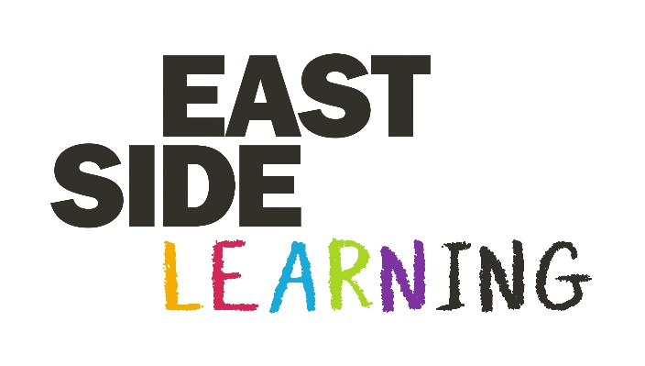

Procurement of Services for the
Family to Family Early Years Programme

Requirement

EastSide Partnership is seeking to procure the following services, to be undertaken between 21st January and 31st March 2019 for the Family to Family programme:

- Research/Survey work
- Set up and Facilitation of events
- Recruitment of participants
- Monitoring and evaluation of activities

The daily rate is £125 per day on a contract for services basis. The successful applicant(s) will be responsible for payment of Income Tax, National Insurance and any other statutory financial obligations.

About the programme

The Family to Family programme is targeted at practitioners in early years settings and parents of pre-school children. It aims to raise awareness of opportunities to integrate good relations practice in early years settings and enable the wider family networks involved to learn more about their community and diversity.

The programme will be delivered through EastSide Learning (EastSide Partnership) and is funded by the Executive Office Good Relations Programme.

Application

Interested providers are required to:
- Submit a CV and cover letter for consideration – this should include details of relevant experience delivering any/all of the above services
- Indicate in your cover letter that you are available to undertake the service(s) between 21st January and 31st March

CV and cover letter should be returned to Eddy Baker by email eddy@eastsidepartnership.com by 5pm on Wednesday 16th January.

